**INTRODUCTION**

**1.1. PURPOSE OF AI IN FLASK CHATBOT**

**AI** can use historical data, which in **sports** is well documented, to predict the future potential of players before investing in them. It can also be used to estimate players' market values to make the right offers while acquiring new talent.

**1.2. What is AI?**

AI is a t**e**chnique that enables machines to mimic human behavior artificial intelligence is the theory and development of computer systems able to perform tasks normally requiring human intelligence such as visual perception speech recognition decision-making and translation between languages.

Now the term artificial intelligence was actually coined way back in 1956 by John McCarthy or professor at Dartmouth for years it was thought that computers would never match the power of the human brain but it has proven to not be the case well back then we did not have enough data and reputation per hour but now with big data coming into existence with the great advent of cheap use artificial intelligence is much possible.

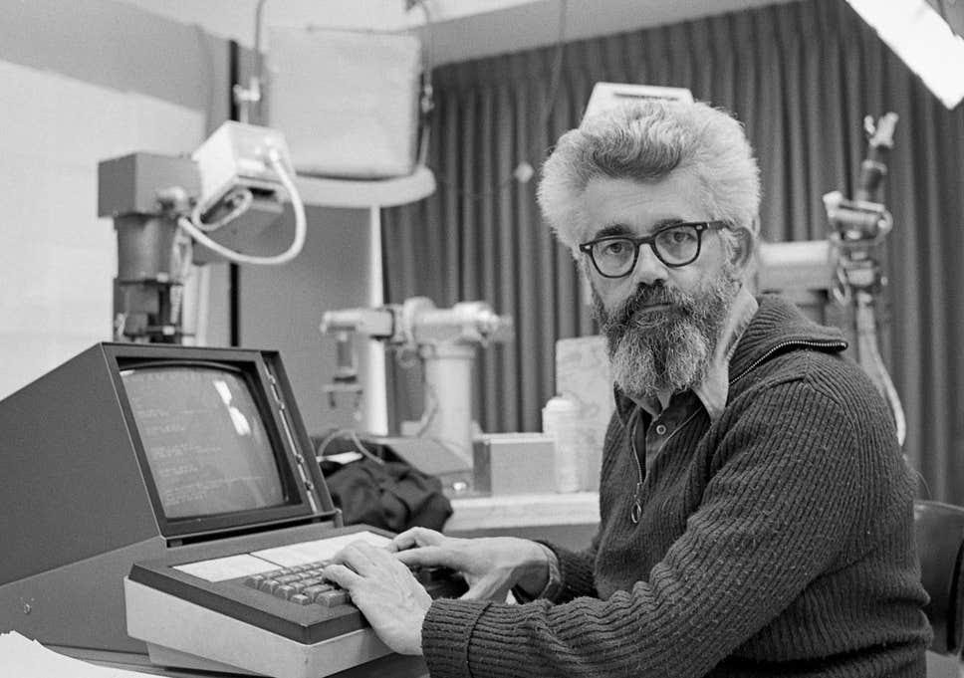

Figure 1: John McCarthy

Now this artificial intelligence machine learning and deep end they all come under the roof of data science well data science is something that has been there for ages and data science is the extraction of knowledge from beta by using different techniques and algorithms.

Now artificial intelligence is the technique which enables machine to mimic human behavior and the idea behind here is fairly simple yet fascinating which is to make intelligent machines that can take decisions on its own now machine learning is a subset of artificial intelligence technique which uses statistical methods to enable machines to improve with experience.

Now deep learning as we know is a subset of machine learning which makes the same computation of multi-layer neural network feasible and uses neural networks to stimulate brain like decision making.

The importance of artificial intelligence it automates repetitive learning and discovery through data paper forms frequent high-volume computerized us reliably and without fatigue.

Ai adapts through progressive learning algorithms to let the data do the programming the algorithm becomes a classifier or a predictor so just as the algorithm can teach itself how to play any game it can teach itself what product to recommend next online it analyzes more and deeper data using neural networks that have many hidden layers you need lots of data and to Train deep learning models because they learn directly from the data the more data you can feed them the more accurate they become now a achieves incredible accuracy its route to planning neural networks.

There are two types of artificial intelligence and the first one is the narrow AI and the second one is the broad Ai.

Narrow a narrow AI is an artificial intelligence system that is designed and trained for one particular task now virtual assistance such as Amazon's Alexi the APUs CV used in Aero AI known area is sometimes also referred to as weak Ai Howard that does not mean that narrow area is inefficient or something of that sort on the contrary it is extremely good at routine jobs both physical and cognitive it is narrow AI that is threatening to replace many human jobs throughout the world.

wide AI is that why dia is a system with cognitive abilities so that when the system is presented with an unfamiliar task it is intelligent enough to find a solution now here the system is capable of having intelligent behavior across a variety of tasks from driving a car to telling a joke and the techniques aim at replicating and surpassing many capabilities of human intelligence such as risk analysis and other cognitive processes

the robots today are machine learning enabled tools that provide doctors with extended precision and control now these machines enables shortening the patient's hospital stay positive affecting the surgical experience and reducing the medical cost all at once

different domains of artificial intelligence first of all we have neural networks so neural networks are a class of models within the general machine learning literature and they are specific set of algorithms that have revolutionized machine learning and artificial intelligence

1.3. **What is Machine Learning?**

 Well, Machine Learning is a concept which allows the machine to learn from examples and experience, and that too without being explicitly programmed. So instead of you writing the code, what you do is you feed data to the generic algorithm, and the algorithm/ machine builds the logic based on the given data.

* **Types of Machine Learning**

Machine learning is sub-categorized to three types:

**Machine Learning**

**Reinforcement Learning**

**Unsupervised Learning**

**Supervised Learning**

## Fig:1.2 Types of Machine Learning

## What is Supervised Learning?

Supervised Learning is the one, where you can consider the learning is guided by a teacher. We have a dataset which acts as a teacher and its role is to train the model or the machine. Once the model gets trained it can start making a prediction or decision when new data is given to it.

## What is Unsupervised Learning?

The model learns through observation and finds structures in the data. Once the model is given a dataset, it automatically finds patterns and relationships in the dataset by creating clusters in it. What it cannot do is add labels to the cluster, like it cannot say this a group of apples or mangoes, but it will separate all the apples from mangoes.

## What is Reinforcement Learning?

It is the ability of an agent to interact with the environment and find out what is the best outcome. It follows the concept of hit and trial method. The agent is rewarded or penalized with a point for a correct or a wrong answer, and on the basis of the positive reward points gained the model trains itself. And again once trained it gets ready to predict the new data presented to it.

1.4. **What is Deep Learning?**

Deep learning is one of the only methods by which we can overcome the challenges of feature extraction. This is because deep learning models are capable of learning to focus on the right features by themselves, requiring little guidance from the programmer. Basically, deep learning mimics the way our brain functions i.e. it learns from experience. As you know, our brain is made up of billions of neurons that allows us to do amazing things. Even the brain of a one year old kid can solve complex problems which are very difficult to solve even using super-computers. For example:

Recognize the face of their parents and different objects as well.

Discriminate different voices and can even recognize a particular person based on his/her voice.

Draw inference from facial gestures of other persons and many more.

Actually, our brain has sub-consciously trained itself to do such things over the years. Now, the question comes, how deep learning mimics the functionality of a brain? Well, deep learning uses the concept of artificial neurons that functions in a similar manner as the biological neurons present in our brain. Therefore, we can say that Deep Learning is a subfield of machine learning concerned with algorithms inspired by the structure and function of the brain called artificial neural networks.

* **How Deep Learning Works?**

In an attempt to re-engineer a human brain, Deep Learning studies the basic unit of a brain called a brain cell or a neuron. Inspired from a neuron an artificial neuron or a perceptron was developed. Now, let us understand the functionality of biological neurons and how we mimic this functionality in the perceptron or an artificial neuron:

If we focus on the structure of a biological neuron, it has dendrites which is used to receive inputs. These inputs are summed in the cell body and using the Axon it is passed on to the next biological neuron as shown in the above image.

Similarly, a perceptron receives multiple inputs, applies various transformations and functions and provides an output.

As we know that our brain consists of multiple connected neurons called neural network, we can also have a network of artificial neurons called perceptrons to form a Deep neural network. So, let’s move ahead in this Deep Learning Tutorial to understand how a Deep neural network looks like.

Any Deep neural network will consist of three types of layers:

* The Input Layer

the first layer is the input layer which receives all the inputs and the last layer is the output layer which provides the desired output.

* The Hidden Layer

All the layers in between these layers are called hidden layers. There can be n number of hidden layers thanks to the high end resources available these days.

* The Output Layer

The number of hidden layers and the number of perceptrons in each layer will entirely depend on the use-case you are trying to solve.

**1.5 Relation between Ai, Machine learning and Deep learning**

Artificial Intelligence makes it possible for the machines to learn from their experience. The machines adjust their response based on new inputs thereby performing human-like tasks by processing large amounts of data and recognizing patterns in them.

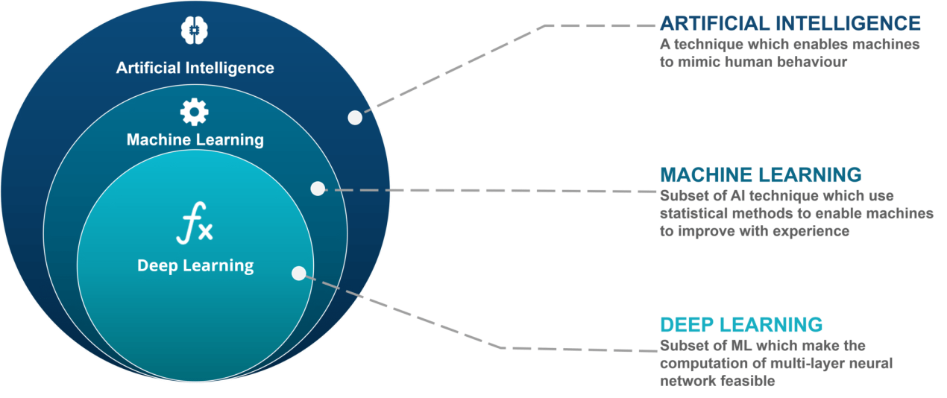

Figure -1.3 the relation between AI, Machine learning and Deep learning

The first church took generations to finish, so most of the workers working on it never saw the final outcome. Those working on it took pride in their craft, building bricks and chiselling stones that were to be placed into the Great Structure. So, as AI researchers, we should think ourselves as humble brick makers, whose job it is to study how to build components (e.g. parsers, planners, learning algorithms, etc) that someday someone, somewhere, will integrate into intelligent systems.

Some of the examples of Artificial Intelligence from our day to day life are Apple’s Siri, the chess-playing computer, tesla’s self-driving car and many more. These examples are based on deep learning and natural language processing.

Machine Learning is a subset of artificial intelligence. It allows the machines to learn and make predictions based on its experience (data).

Deep learning is a particular kind of machine learning that achieves great power and flexibility by learning to represent the world as nested hierarchy of concepts or abstraction.

The concept of deep learning is not new. But recently its hype has increased, and deep learning is getting more attention. This field is a special kind of machine learning which is inspired by the functionality of our brain cells called artificial neural network. It simply takes data connections between all artificial neurons and adjusts them according to the data pattern. More neurons are needed if the size of the data is large. It automatically features learning at multiple levels of abstraction thereby allowing a system to learn complex functions mapping without depending on any specific algorithm.

**1.6 Advantage of Deep learning over Machine learning**

### Reduction in Human Error

The phrase “**human error**” was born because humans make mistakes from time to time. Computers however, do not make these mistakes if they are programmed properly. With [Artificial intelligence](https://www.edureka.co/blog/artificial-intelligence-tutorial/), the decisions are taken from the previously gathered information applying certain set of algorithms. So errors are reduced and the chance of reaching accuracy with a greater degree of precision is a possibility.

**Example:**In Weather Forecasting using AI they have reduced majority of human error.

### Takes risks instead of Humans

This is one of the biggest [advantage of Artificial intelligence](https://www.edureka.co/blog/benefits-of-artificial-intelligence/). We can overcome many risky limitations of human by developing an AI Robot which in turn can do the risky things for us. Let it be going to mars, defuse a bomb, explore the deepest parts of oceans, minning for coal and oil, it can be used effectively in any kinds of nautural or man made disasters.

**Example:**Have you heard about the **Chernoby**l nuclear power plant explosion in Ukraine? At that time there were no AI powered robots which can help us to minimise the affect of radiation by controlling the fire in early stages, as any human went close to the core was dead in matter of minutes. They eventually poured sand and boron from helichopters from a mere distance.

AI Robots can be used in such situations where an human intervention can be hazardous.

### Available 24×7

An Average human will work for 4-6 hours a day excluding the breaks. Humans are built in such a way to get some time out for refereshing themselves and get ready for a new day of work and they even have weekly off’s to stay intact with their work life and personal life. But using AI we can make machines work 24×7 without any breaks and they don’t even get bored unlike humans.

**Example:**Educational Institutes and Helpline centers are getting many queries and issues which can be handled effecively using AI.

### Helping in Repetitive Jobs

In our day-to-day work, we will be performing many repetitive works like sending a thanking mail, verifying certain documents for errors and many more things. Using artificial intelligence we can productively automate these mundane tasks and can even remove “**boring**” tasks for humans and free them up to be increasingly creative.

**Example:**In banks, we often see many verifications of documents in order to get a loan which is a repetitive task for the owner of the bank. Using AI Cognitive Automation the owner can speed up the process of verifying the documents by which both the customers and the owner will be benefited.

### Digital Assistance

Some of the highly advanced organizations use digital assistants to interact with users which saves the need of human resource. The digital assistant also used in many websites to provide things that user want. We can chat with them about what we are looking for. Some chatbots are designed in such a way that it becomes hard to determine that we’re chatting with a chatbot or a human being.

**Example:**We all know that organizations have a customer support team which needs to clarify the doubts and queries of the customers. Using AI the organizations can set up a Voicebot or Chatbot which can help customers with all their queries. We can see many organizations already started using them in their websites and mobile applications.

### Faster Decisions:

Using AI alongside other technologies we can make machines take decisions faster than a human and carry out actions quicker. While taking a decision human will analyze many factors both emotionally and practically but AI-powered machine works on what it is programmed and delivers the results in a faster way.

**Example:**We all have played a Chess game in Windows. It is nearly impossible to beat CPU in the hard mode because of the AI behind that game. It will take the best possible step in a very short time according to the algorithms used behind it.

### Daily Applications

Daily applications such as Apple’s **Siri**, Window’s **Cortana**, Google’s **OK Google** are frequently used in our daily routine whether it is for searching a location, taking a selfie, making a phone call, replying to a mail and many more.

**Example:**Around 20 years ago, when we are planning to go somewhere we used to ask a person who already went there for the directions. But now all we have to do is say “**OK Google**where is Visakhapatnam”. It will show you Visakhapatnam’s location on google map and best path between you and Visakhapatnam.

### New Inventions:

AI is powering many inventions in almost every domain which will help humans solve the majority of complex problems.

**1.7 Limitation of Deep learning**

In deep learning, everything is a vector, i.e. everything is a point in a geometric space. Model inputs (it could be text, images, etc) and targets are first "vectorized", i.e. turned into some initial input vector space and target vector space. Each layer in a deep learning model operates one simple geometric transformation on the data that goes through it. Together, the chain of layers of the model forms one very complex geometric transformation, broken down into a series of simple ones. This complex transformation attempts to maps the input space to the target space, one point at a time. This transformation is parametrized by the weights of the layers, which are iteratively updated based on how well the model is currently performing. A key characteristic of this geometric transformation is that it must be differentiable, which is required in order for us to be able to learn its parameters via gradient descent. Intuitively, this means that the geometric morphing from inputs to outputs must be smooth and continuous—a significant constraint.

The whole process of applying this complex geometric transformation to the input data can be visualized in 3D by imagining a person trying to uncrumple a paper ball: the crumpled paper ball is the manifold of the input data that the model starts with. Each movement operated by the person on the paper ball is similar to a simple geometric transformation operated by one layer. The full uncrumpling gesture sequence is the complex transformation of the entire model. Deep learning models are mathematical machines for uncrumpling complicated manifolds of high-dimensional data.

That's the magic of deep learning: turning meaning into vectors, into geometric spaces, then incrementally learning complex geometric transformations that map one space to another. All you need are spaces of sufficiently high dimensionality in order to capture the full scope of the relationships found in the original data.

• **The limitations of deep learning**

The space of applications that can be implemented with this simple strategy is nearly infinite. And yet, many more applications are completely out of reach for current deep learning techniques—even given vast amounts of human-annotated data. Say, for instance, that you could assemble a dataset of hundreds of thousands—even millions—of English language descriptions of the features of a software product, as written by a product manager, as well as the corresponding source code developed by a team of engineers to meet these requirements. Even with this data, you could not train a deep learning model to simply read a product description and generate the appropriate codebase. That's just one example among many. In general, anything that requires reasoning—like programming, or applying the scientific method—long-term planning, and algorithmic-like data manipulation, is out of reach for deep learning models, no matter how much data you throw at them. Even learning a sorting algorithm with a deep neural network is tremendously difficult.

This is because a deep learning model is "just" a chain of simple, continuous geometric transformations mapping one vector space into another. All it can do is map one data manifold X into another manifold Y, assuming the existence of a learnable continuous transform from X to Y, and the availability of a dense sampling of X:Y to use as training data. So even though a deep learning model can be interpreted as a kind of program, inversely most programs cannot be expressed as deep learning models—for most tasks, either there exists no corresponding practically-sized deep neural network that solves the task, or even if there exists one, it may not be learnable, i.e. the corresponding geometric transform may be far too complex, or there may not be appropriate data available to learn it.

Scaling up current deep learning techniques by stacking more layers and using more training data can only superficially palliate some of these issues. It will not solve the more fundamental problem that deep learning models are very limited in what they can represent, and that most of the programs that one may wish to learn cannot be expressed as a continuous geometric morphing of a data manifold.

**• The risk of anthropomorphizing machine learning models**

One very real risk with contemporary AI is that of misinterpreting what deep learning models do, and overestimating their abilities. A fundamental feature of the human mind is our "theory of mind", our tendency to project intentions, beliefs and knowledge on the things around us. Drawing a smiley face on a rock suddenly makes it "happy"—in our minds. Applied to deep learning, this means that when we are able to somewhat successfully train a model to generate captions to describe pictures, for instance, we are led to believe that the model "understands" the contents of the pictures, as well as the captions it generates. We then proceed to be very surprised when any slight departure from the sort of images present in the training data causes the model to start generating completely absurd captions.

**[1.8 Python as a programming language](https://www.edureka.co/ai-deep-learning-with-tensorflow" \t "_blank)**

## **[Python In Artificial Intelligence](https://www.edureka.co/ai-deep-learning-with-tensorflow" \t "_blank)**

[One of the key features of python language is its simplicity in code writing. It uses 1/5](https://www.edureka.co/ai-deep-learning-with-tensorflow" \t "_blank)[th](https://www.edureka.co/ai-deep-learning-with-tensorflow" \t "_blank)[of the code when compared to other object oriented programs. This factor makes it the most sort after language used in trending domains like AI. AI has a wide horizon under which it deals with machine learning and deep learning.](https://www.edureka.co/ai-deep-learning-with-tensorflow" \t "_blank)

[Python has a variety of libraries that appeal to the needs of any programmer. It has some prebuilt libraries such as](https://www.edureka.co/ai-deep-learning-with-tensorflow" \t "_blank)[[Numpy](https://www.edureka.co/ai-deep-learning-with-tensorflow" \t "_blank)](https://www.edureka.co/blog/python-numpy-tutorial/)[,](https://www.edureka.co/ai-deep-learning-with-tensorflow" \t "_blank)[[SciPy](https://www.edureka.co/ai-deep-learning-with-tensorflow" \t "_blank)](https://www.edureka.co/blog/scipy-tutorial/)[, Pybrain etc., which are for advance and scientific computing. Python is platform independent, which makes it quite flexible in interfacing between other technologies. In addition, the current user base of the language is very diverse. Most python developers share queries and solutions on portals, which make it a comprehensive knowledge resource as well.](https://www.edureka.co/ai-deep-learning-with-tensorflow" \t "_blank)

[The language not only applies OOPs concepts but incorporates a scripting approach as well. There are numerous IDEs (Integrated Development Environment) like](https://www.edureka.co/ai-deep-learning-with-tensorflow" \t "_blank)[[PyCharm](https://www.edureka.co/ai-deep-learning-with-tensorflow" \t "_blank)](https://www.edureka.co/blog/pycharm-tutorial)[, which allows users to carry out complex codes and algorithms of AI related projects. In an AI’s SDLC (Software Development Life Cycle) phase like testing, debugging and development, it becomes a cakewalk, when compared against other contemporary programming languages like Java, Javascript and Pearl.](https://www.edureka.co/ai-deep-learning-with-tensorflow" \t "_blank)

[These languages would definitely yield desired results but would make tasks cumbersome. Hence, looking at the numerous advantages of python, there is no doubt that it plays a crucial aspect in today’s AI technologies.](https://www.edureka.co/ai-deep-learning-with-tensorflow" \t "_blank)

## **[Deep Learning In Python](https://www.edureka.co/ai-deep-learning-with-tensorflow" \t "_blank)**

[Deep learning is another trending domain in todays’ world of Artificial Intelligence. Deep learning techniques are so powerful because they represent and learn of how to solve a problem in the best possible way. This is called as “Representation Learning”.  The deep learning programs are trained with numerous examples that make its predictions accurate. Deep learning models are extensively used in colorizing images and videos. It is used in identification of objects in photographs popularly termed as ‘face-recognition’.](https://www.edureka.co/ai-deep-learning-with-tensorflow" \t "_blank)

[Python is the best platform to get started with deep learning models. Python is quick and easy to understand. It has a ton of features that make deep learning projects faster to operate and develop. The two most versatile libraries used by any deep learning expert is “Theano” and “](https://www.edureka.co/ai-deep-learning-with-tensorflow" \t "_blank)[[Tensorflow](https://www.edureka.co/ai-deep-learning-with-tensorflow" \t "_blank)](https://www.edureka.co/blog/tensorflow-tutorial/)[”. These are quiet technical and used exhaustively by research groups. The “Keras” library is written in pure python which provides an interface for the above two libraries.](https://www.edureka.co/ai-deep-learning-with-tensorflow" \t "_blank)

* **[Python As A Programming Language](https://www.edureka.co/ai-deep-learning-with-tensorflow" \t "_blank)**

[Now that we know how important Python is to the world and us. Let us deep dive into learning some of the technical aspects of the programming language. The below illustrated topics are rudimentary and would be easy to grasp.](https://www.edureka.co/ai-deep-learning-with-tensorflow" \t "_blank)

**1.9 Python use in machine learning**

Machine Learning, as the name suggests, is the science of programming a computer by which they are able to learn from different kinds of data. A more general definition given by Arthur Samuel is – “Machine Learning is the field of study that gives computers the ability to learn without being explicitly programmed.” They are typically used to solve various types of life problems.  
In the older days, people used to perform Machine Learning tasks by manually coding all the algorithms and mathematical and statistical formula. This made the process time consuming, tedious and inefficient. But in the modern days, it is become very much easy and efficient compared to the olden days by various python libraries, frameworks, and modules. Today, Python is one of the most popular programming languages for this task and it has replaced many languages in the industry, one of the reason is its vast collection of libraries. Python libraries that used in Machine Learning are:

* Numpy
* Scipy
* Scikit-learn
* Pandas
* Matplotlib
* NumPy is a very popular python library for large multi-dimensional array and matrix processing, with the help of a large collection of high-level mathematical functions. It is very useful for fundamental scientific computations in Machine Learning. It is particularly useful for linear algebra, Fourier transform, and random number capabilities. High-end libraries like TensorFlow uses NumPy internally for manipulation of Tensors.

|  |
| --- |
| # Python program using NumPy  # for some basic mathematical  # operations    import numpy as np    # Creating two arrays of rank 2  x = np.array([[1, 2], [3, 4]])  y = np.array([[5, 6], [7, 8]])    # Creating two arrays of rank 1  v = np.array([9, 10])  w = np.array([11, 12])    # Inner product of vectors  print(np.dot(v, w), "\n")    # Matrix and Vector product  print(np.dot(x, v), "\n")    # Matrix and matrix product  print(np.dot(x, y)) |

**Output:**

219

[29 67]

[[19 22]

[43 50]]

Figure 1.4 :The output of above program

* SciPy is a very popular library among Machine Learning enthusiasts as it contains different modules for optimization, linear algebra, integration and statistics. There is a difference between the SciPy library and the SciPy stack. The SciPy is one of the core packages that make up the SciPy stack. SciPy is also very useful for image manipulation.

# Python script using Scipy

# for image manipulation

from scipy.misc import imread, imsave, imresize

# Read a JPEG image into a numpy array

img = imread('D:/Programs / cat.jpg') # path of the image

print(img.dtype, img.shape)

# Tinting the image

img\_tint = img \* [1, 0.45, 0.3]

# Saving the tinted image

imsave('D:/Programs / cat\_tinted.jpg', img\_tint)

# Resizing the tinted image to be 300 x 300 pixels

img\_tint\_resize = imresize(img\_tint, (300, 300))

# Saving the resized tinted image

imsave('D:/Programs / cat\_tinted\_resized.jpg', img\_tint\_resize)

**output:**

****

**Original image:**

**Tinted image:**

**Resized tinted image:**

Figure 1.5 output of above program

* Skikit-learn is one of the most popular ML libraries for classical ML algorithms. It is built on top of two basic Python libraries, viz., NumPy and SciPy. Scikit-learn supports most of the supervised and unsupervised learning algorithms. Scikit-learn can also be used for data-mining and data-analysis, which makes it a great tool who is starting out with ML.

# Python script using Scikit-learn

# for Decision Tree Clasifier

# Sample Decision Tree Classifier

from sklearn import datasets

from sklearn import metrics

from sklearn.tree import DecisionTreeClassifier

# load the iris datasets

dataset = datasets.load\_iris()

# fit a CART model to the data

model = DecisionTreeClassifier()

model.fit(dataset.data, dataset.target)

print(model)

# make predictions

expected = dataset.target

predicted = model.predict(dataset.data)

# summarize the fit of the model

print(metrics.classification\_report(expected, predicted))

print(metrics.confusion\_matrix(expected, predicted))

**Output:**

DecisionTreeClassifier(class\_weight=None, criterion='gini', max\_depth=None,

max\_features=None, max\_leaf\_nodes=None,

min\_impurity\_decrease=0.0, min\_impurity\_split=None,

min\_samples\_leaf=1, min\_samples\_split=2,

min\_weight\_fraction\_leaf=0.0, presort=False, random\_state=None,

splitter='best')

precision recall f1-score support

0 1.00 1.00 1.00 50

1 1.00 1.00 1.00 50

2 1.00 1.00 1.00 50

micro avg 1.00 1.00 1.00 150

macro avg 1.00 1.00 1.00 150

weighted avg 1.00 1.00 1.00 150

[[50 0 0]

[ 0 50 0]

[ 0 0 50]]

Figure 1.6 :output of the above program

* Pandas is a popular Python library for data analysis. It is not directly related to Machine Learning. As we know that the dataset must be prepared before training. In this case, Pandas comes handy as it was developed specifically for data extraction and preparation. It provides high-level data structures and wide variety tools for data analysis. It provides many inbuilt methods for groping, combining and filtering data.

# Python program using Pandas for

# arranging a given set of data

# into a  table

# importing pandas as pd

import pandas as pd

data = {"country": ["Brazil", "Russia", "India", "China", "South Africa"],

       "capital": ["Brasilia", "Moscow", "New Dehli", "Beijing", "Pretoria"],

       "area": [8.516, 17.10, 3.286, 9.597, 1.221],

       "population": [200.4, 143.5, 1252, 1357, 52.98] }

data\_table = pd.DataFrame(data)

print(data\_table)

**Output:**  
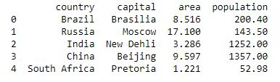

Figure 1.7: output of above program

* Matpoltlib is a very popular Python library for data visualization. Like Pandas, it is not directly related to Machine Learning. It particularly comes in handy when a programmer wants to visualize the patterns in the data. It is a 2D plotting library used for creating 2D graphs and plots. A module named pyplot makes it easy for programmers for plotting as it provides features to control line styles, font properties, formatting axes, etc. It provides various kinds of graphs and plots for data visualization, viz., histogram, error charts, bar chats, etc.

# Python program using Matplotib

# for forming a linear plot

# importing the necessary packages and modules

import matplotlib.pyplot as plt

import numpy as np

# Prepare the data

x = np.linspace(0, 10, 100)

# Plot the data

plt.plot(x, x, label ='linear')

# Add a legend

plt.legend()

# Show the plot

plt.show()

**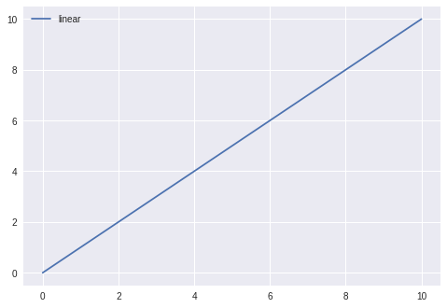Output:**

Figure 1.8: output of above prgram

**1.10. Packages use in project:**

**1.10.1 NUMPY :**

**NumPy** – which stands for numerical Python; It is a library consisting of multidimensional, array objects and collection of routines on processing those always. NumPy helps to perform mathematical and logical operation on array.

**Operation using NumPy:**

**.** Mathematical and logical on array.

**.** Furrier transforms and routines for shape manipulation.

**.** Operation related to linear algebra and in build functions for linear

Algebra and random number generation.

NumPy is often used along with packages like spicy (scientific Python) and MatPlotlib (Plotting library)

Import NumPy as me the most import object define in NumPy is an n dimensional array type called nd array.

import NumPy a np

a = np.array ([1, 2, 3])

Print a

**Output: -**

[1, 2, 3]

import NumPy as np

a= np.array ([[12, 3],[4,5,6]])

Print a.Shape

**Output:**

(2, 3)

**1.10.2 : PANDAS**

Pandas is an open source library that allows to you performs data manipulation. Pandas library is built on top of NumPy. Pandas need NumPy to operands, it’s provided and easy way to create manipulates the data. It uses series on 1D data structure and DataFrame for multidimensional data structure. It provided slides the data, merge, concatenate, reshape the data.

* **What is DataFrame?**

A DataFrame is a 2D array with labels 2D access (row and Colum). It is standard way to data.

|  |  |  |
| --- | --- | --- |
|  | Item | Price |
| 0 | A | 2 |
| 1 | B | 3 |

* **Create a data frame**

We can convert a numpy array to a pandas DataFrame with pd.DataFrame( ) . Here opposite is also possible, using np.array( ) that we can perfrom in a operation.

* **Numpy to pandas**

Import numpy as np

h = [ [ 1, 2 ], [ 3,4] ]

table\_h = pd.DataFrame(h)

print(‘DataFrame : ’ table\_h)

* **Pandas to Numpy**

array\_h = np.array(table\_h)

print(‘Numpy\_array : ’ array\_h)

* **output**

|  |  |  |
| --- | --- | --- |
|  | 0 | 1 |
| 0 | 1 | 2 |
| 1 | 3 | 4 |

DataFrame

Numpy array : [ [ 1, 2 ] , [ 3, 4 ] ]

* We have use directory to create a pandas DataFrame :

Dic = { ‘Name’ : [ “JOHN”, “SMITH” ], ‘AGE’ : [ 30, 40 ]}

Pd.DataFrame ( Data = Dic )

|  |  |  |
| --- | --- | --- |
|  | AGE | NAME |
| 0 | 30 | JOHN |
| 1 | 40 | SMITH |

**OUTPUT:**

* **Rangedata :**
* **Create data :**

Date\_D = PD.Date\_range ( ‘2030 01 01’, priodes = 6, freq = ‘D’

Print ( ‘Day : ‘. Dates\_D)

**OUTPUT:**

Day : DatetimeIndex ( [ ‘2030-01-01’, ‘2030-01-02’, ‘2030-01-03’, ‘2030-01-04’, ‘2030-01-05’, ‘2030-01-06’ ], Dtye = ‘datatime64 [ ns ]’, freq = ‘D’)

* **Inspecting data :-**

We can check the head or tail of the dataset

Step 1 : Craete rando, sequence with numpy. The sequence has 4 coloums and 6 rows.

Randon = np.random . rand n ( 6,4 )

Setp 2 : Then create a data frame using pandas ; Use data\_m as an index for the DataFrame. It means each row will be given an name or index corresponding to a date.

CRATE WITH DATE:

df = pd.DataFrame ( random, index = date\_m, coloms = list ( ‘ABCD’ ) )

Step 3 : df .head (3)

**OUTPUT :**

|  |  |  |  |
| --- | --- | --- | --- |
|  | A | B | C |
| 2030-01-31 | 1.3 | 1.31 | 1.312 |
| 2030-02-28 | 2 | 4 | 6 |
| 2030-03-31 | 7 | 8 | 9 |

**1.10.3 : Matplotlib :-**

It is a ploting library for the python programming language and it’s nemarical mathe,atics extension. Numpy using these package we can generates plots, histograms, power spectra, bar charts, error charts, scatter diagram etc.

Import matplotlib . pyplot as plt

**Alias**

* **The code will be: –**

X\_values = [0, 1, 2, 3, 4, 5]

Squares = [0, 1, 4, 9, 16, 25]

Plt.plot (x\_values, squares)

Plt.show ( )

* **Bar graph :-**

X\_values = [50, 60, 10, 70, 30]

Y\_values = [ “a”, “b”, “c”, “d”, “e” ]

Plt.bar (Y\_values, X\_values, color = “Red” )

Plt.show ( )

* **Different between Seaborn and matplotlib** :-

Seaborn is complimentary to matplotlib and it specially tergates statistical data visualization. Seaborn extends matplotlib and thats why it cab address, limitation of matplotlib , seaborn work with different paremeter. The matplotlib defaults that usually don’t speak to users are the colors, tick marks, styles.To load dataset in seaborn we need to use -

**load\_dataset ( )** method.

* **HEATMAP IN PYTHON:**

A heatmap is a 2D graphical representation of data where the individual values that are containing in are representated as columns. It represents different colour coding to represents different values the heatmaps can be use to show where users have clicked on a page, how far they have scroll down a page.

A correlation heatmap uses colour cells, typically in a monochromatic scall, to show a 2D correlation matrix, the colour value of the cells is proportional to the number of measurement that match the dimension values.

* **Python Heatmap Code**

We will create a seaborn heatmap for a group of 30 Pharmaceutical Company stocks listed on the National Stock Exchange of India Ltd (NSE). The seaborn heatmap will display the stock symbols and its respective single-day percentage price change.

We collate the required market data on Pharma stocks and construct a comma-separated value (CSV) file comprising of the stock symbols and their respective percentage price change in the first two columns of the CSV file.

Since we have 30 Pharma companies in our list, we will create a heatmap matrix of 6 rows and 5 columns. Further, we want our seaborn heatmap to display the percentage price change for the stocks in a descending order. To that effect, we arrange the stocks in a descending order in the CSV file and add two more columns which indicate the position of each stock on X & Y axis of our heatmap.

## **Import the required Python packages**

We import the following Python packages:

* 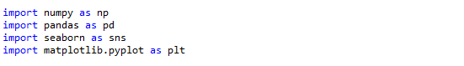**Load the dataset**

We read the dataset using the read\_csv function from pandas and visualize the first ten rows using the print statement.

### **Create a Python Numpy array**

Since we want to construct a 6 x 5 matrix, we create an n-dimensional array of the same shape for “Symbol” and the “Change” columns.

### **Create a Pivot in Python**

The [pivot](http://pandas.pydata.org/pandas-docs/stable/generated/pandas.DataFrame.pivot.html) function is used to create a new derived table from the given data frame object “df”. The function takes three arguments; index, columns, and values. The cell values of the new table are taken from column given as the values parameter, which in our case is the “Change” column.

### **Create an Array to Annotate the Heatmap**

In this step, we create an array which will be used to annotate the seaborn heatmap. We call the flatten method on the “symbol” and “percentage” arrays to flatten a Python list of lists in one line. The zip function which returns an iterator [zips a list in Python](http://stackoverflow.com/questions/13704860/zip-lists-in-python). We run a Python For loop and by using the format function; we format the stock symbol and the percentage price change value as per our requirement.

### **Create the Matplotlib figure and define the plot**

We create an empty Matplotlib plot and define the figure size. We also add the title to the plot and set the title’s font size, and its distance from the plot using the set\_position method.

We wish to display only the stock symbols and their respective single-day percentage price change. Hence, we hide the ticks for the X & Y axis, and also remove both the axes from the heatmap plot.

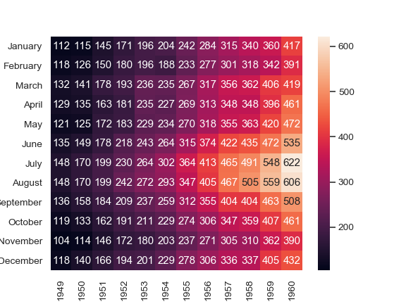

**1.10:4 Sk\_learn :-**

scikit – learn is an open source python library that implements a range of machine learning algorithms

* + - Simple tool for datamining and analysis :- It’s features various classification, regration, clustering algorithms, including support vector machine, Random forests, fradient boosting, K- means algorithms.
    - It works with NUMPY, SYPY the easiest way to install scikit learn.

pip install \_ - U\_scikit\_learn

* Load the dataset, a dataset is nothing but a collection of data, a dataset has 2 main components -
* Features
* Response
* **Features** : They can simply variables of our data, they can be more than one and represented by a feature matrix
* **Response** : This is the output variable depending on the feature variable

// Load the iris dataset as an example.

**from \_sklearn . datasets\_import load\_iris**

**Iris = load\_iris ( )**

// store the feature matrix and respose vector

**X = iris . daya # we are saving the feature to x**

**Y = iris . target # response**

# Store the feature and target names,

feature\_names = iris .feature\_names

target \_names = iris. target \_names

print( type ( x ) )

print ( X [ : 5 ] )

**1.11 PROBLEM DOMAIN**

Assuming to the problem domain, we can see from the above discussion of the project (Scocer winning prediction using deep learning) that is the accuracy level of our machine learning model is to be 80% to 90% depending upon the strength of training and testing dataset.As much more accurate data we gather the result is to be much more accurate depending on our machine learning model.

If we want to predict the accurate level of a winning scocer match then first of all we have to collect the match and players information that works as a feature of our dataset after train and test those data we get a accurate result that is 80% to 90% accurate and predict the winning team of the match.

**1.12 SOLUTION DOMAIN**

**Evolutionary Model**

This model has many of the features of the incremental model. As in case of the increment model, the software is developed over a number of increments. At each increment, a concept (feature) is implemented and is deployed at the client site. The software is successively refined and feature-enriched until the full software is realised. The principal idea behind the evolutionary life cycle model is conveyed by its name. In the incremental development model, complete requirements are first developed and the SRS document prepared. In contrast, in the evolutionary model, the requirements, plan, estimates, and solution evolve over the iterations, rather than fully defined and frozen in a major up-front specification effort before the development iterations begin. Such evolution is consistent with the pattern of unpredictable feature discovery and feature changes that take place in new product development.

Though the evolutionary model can also be viewed as an extension of the waterfall model, but it incorporates a major paradigm shift that has been widely adopted in many recent life cycle models. Due to obvious reasons, the evolutionary software development process is sometimes referred to as design a little, build a little, test a little deploy a little model. This means that after the requirements have been specified, the design, build, test, and deployment activities are iterated. A schematic representation of the evolutionary mode of development has been shown in Figure .

Rough requirements specification

Identify the core and other parts to be developed incrementally

Develop the core part using an iterative waterfall model

Collect customer feedback and modify requirements

Development the next identified features using an iterative waterfall model

All features complete

Maintenance

**Advantages**

The evolutionary model of development has several advantages. Two important advantages using this model are the following:

* **Effective elicitation of actual customer requirements:**

In this model, the user gets a chance to experiment with a partially developed software much before the complete requirements are developed. Therefore, the evolutionary model helps to accurately elicit user requirements with the help of feedback obtained on the delivery of different versions of the software. As a result, the change requests after delivery of the complete software gets substantially reduced.

* **Easy handling change requests:**

In this model, handling change requests is easier as no long-term plans are made. Consequently, reworks required due to change requests are normally much smaller compared to the sequential models.

**Disadvantages**

The main disadvantages of the successive versions model are as follows:

* **Feature division into incremental parts can be non-trivial:**

For many development projects, especially for small-sized projects, it is difficult to divide the required features into several parts that can be incrementally implemented and delivered. Further, even for larger problems, often the features are so intertwined and dependent on each other that even an expert would need considerable effort to plan the incremental deliveries.

* **Ad hoc design:**

Since at a time design for only the current increment is done, the design can become ad hoc without specific attention being paid to maintainability and optimality. Obviously, for moderate sized problems and for those for which the customer requirements are clear, the iterative waterfall model can yield a better solution.

**Evolutionary versus incremental model of developments**

The evolutionary and incremental have several things in common, such as incremental development and deployment at the client site. However, in a purely incremental model, the requirement specification is completed before any development activities start. Once the requirement specification is completed, the requirements are split into requirements. In a purely evolutionary development, the development of the first version starts off after obtaining a rough understanding of what is required. As the development proceeds, more and more requirements emerge. The modern development models, such as the agile mode e neither purely incremental, nor purely evolutionary, but is somewhat in between and is referred to as incremental and evolutionary model. In this are obtained and specified, but requirements that emerge later are accommodated.

**2.1 DATA ANALYSIS USING AI**

As the word suggests Data Analytics refers to the techniques to analyze data to enhance productivity and business gain.  Data is extracted from various sources and is cleaned and categorized to analyze different behavioral patterns. The techniques and the tools used vary according to the organization or individual.

**2.1.1 Why is Data Analytics important?**

As an enormous amount of data gets generated, the need to extract useful insights is a must for a business enterprise. Data Analytics has a key role in improving your business. Here are 4 main factors which signify the need for Data Analytics:

* **Gather Hidden Insights** – Hidden insights from data are gathered and then analyzed with respect to business requirements.
* **Generate Reports** – Reports are generated from the data and are passed on to the respective teams and individuals to deal with further actions for a high rise in business.
* **Perform Market Analysis** – Market Analysis can be performed to understand the strengths and the weaknesses of competitors.
* **Improve Business Requirement** – Analysis of Data allows improving Business to customer requirements and experience.

## ****Top Tools in Data Analytics****

With the increasing demand for Data Analytics in the market, many tools have emerged with various functionalities for this purpose. Either open-source or user-friendly, the top tools in the data analytics market are as follows.

* [**R programming**](https://www.edureka.co/blog/r-tutorial/) – This tool is the leading analytics tool used for statistics and data modeling. R compiles and runs on various platforms such as UNIX, Windows, and Mac OS. It also provides tools to automatically install all packages as per user-requirement.
* [**Python**](https://www.edureka.co/blog/python-tutorial/) – Python is an open-source, [object-oriented programming](https://www.edureka.co/blog/python-class/) language which is easy to read, write and maintain. It provides various machine learning and visualization libraries such as [Scikit-learn](https://www.edureka.co/blog/scikit-learn-machine-learning/" \t "_blank), [TensorFlow](https://www.edureka.co/blog/tensorflow-tutorial/" \t "_blank), [Matplotlib](https://www.edureka.co/blog/python-matplotlib-tutorial/" \t "_blank), [Pandas](https://www.edureka.co/blog/python-pandas-tutorial/), Keras etc. It also can be assembled on any platform like SQL server, a MongoDB database or JSON
* [**Tableau Public**](https://www.edureka.co/blog/tableau-tutorial/) – This is a free software that connects to any data source such as Excel,  corporate Data Warehouse etc. It then creates visualizations, maps, dashboards etc with real-time updates on the web.
* [**QlikView**](https://www.edureka.co/blog/qlikview-tutorial/) – This tool offers in-memory data processing with the results delivered to the end-users quickly. It also offers data association and data visualization with data being compressed to almost 10% of its original size.
* [**SAS**](https://www.edureka.co/blog/sas-tutorial/) – A programming language and environment for data manipulation and analytics, this tool is easily accessible and can analyze data from different sources.
* **Microsoft Excel** – This tool is one of the most widely used tools for data analytics. Mostly usedfor clients’ internal data, this tool analyzes the tasks that summarize the data with a preview of pivot tables.
* **RapidMiner** – A powerful, integrated platform that can integrate with any data source types such as Access, Excel, Microsoft SQL, Tera data, Oracle, Sybase etc. This tool is mostly used for predictive analytics, such as data mining, text analytics, [machine learning](https://www.edureka.co/blog/what-is-machine-learning/).
* **KNIME** – Konstanz Information Miner (KNIME) is an open-source data analytics platform, which allows you to analyze and model data. With the benefit of visual programming, KNIME provides a platform for reporting and integration through its modular data pipeline concept.
* **OpenRefine** – Also known as GoogleRefine, this data cleaning software will help you clean up data for analysis. It is used for cleaning messy data, the transformation of data and parsing data from websites.
* [**Apache Spark**](https://www.edureka.co/blog/spark-tutorial/) – One of the largest large-scale data processing engine, this tool executes applications in Hadoop clusters 100 times faster in memory and 10 times faster on disk. This tool is also popular for data pipelines and machine learning model development.

**2.3 KNN Algorithm**

## **K nearest neighbors or KNN Algorithm is a simple algorithm which uses the entire dataset in its training phase. Whenever a prediction is required for an unseen data instance, it searches through the entire training dataset for k-most similar instances and the data with the most similar instance is finally returned as the prediction.**

## **How does a KNN Algorithm work?**

The k-nearest neighbors algorithm uses a very simple approach to perform classification. When tested with a new example, it looks through the training data and finds the k training examples that are closest to the new example. It then assigns the most common class label (among those k-training examples) to the test example.

### **What does ‘k’ in kNN Algorithm represent?**

k in kNN algorithm represents the number of nearest neighbor points which are voting for the new test data’s class.

If k=1, then test examples are given the same label as the closest example in the training set.

If k=3, the labels of the three closest classes are checked and the most common (i.e., occurring at least twice) label is assigned, and so on for larger k.

## KNN Algorithm - k=3 - edureka

Figure 2.5 **kNN Algorithm represent**

## **KNN Algorithm Manual Implementation**

### **Step1:**Calculate the Euclidean distance between the new point and the existing points

**Step 2:**Choose the value of K and select K neighbors closet to the new point.

### **Step 3:**Count the votes of all the K neighbors / Predicting Values

* **Implementation of kNN Algorithm using Python**
* **Handling the data**

The very first step will be handling the iris dataset. Open the dataset using the open functionand read the data lines with the reader function available under the csv  module.

* **Calculate the distance**

In order to make any predictions, you have to calculate the distance between the new point and the existing points, as you will be needing k closest points.

* **Find k nearest point**

Now that you have calculated the distance from each point, we can use it collect the k most similar points/instances for the given test data/instance.

* **Predict the class**

Now that you have the k nearest points/neighbors for the given test instance, the next task is to predicted response based on those neighbors

* **Check the accuracy**

Now that we have all of the pieces of the KNN algorithm in place. Let’s check how accurate our prediction.

**2.4 DECISION TREE CLASSIFIER**

A***Decision Tree*** has many analogies in real life and turns out, it has influenced a wide area of **Machine Learning**, covering both **Classification** and**Regression**. In decision analysis, a decision tree can be used to visually and explicitly represent decisions and decision making.

* **What is a Decision Tree?**

A decision tree is a map of the possible outcomes of a series of related choices. It allows an individual or organization to weigh possible actions against one another based on their costs, probabilities, and benefits.

As the name goes, it uses a tree-like model of decisions. They can be used either to drive informal discussion or to map out an algorithm that predicts the best choice mathematically.

A decision tree typically starts with a single node, which branches into possible outcomes. Each of those outcomes leads to additional nodes, which branch off into other possibilities. This gives it a tree-like shape.

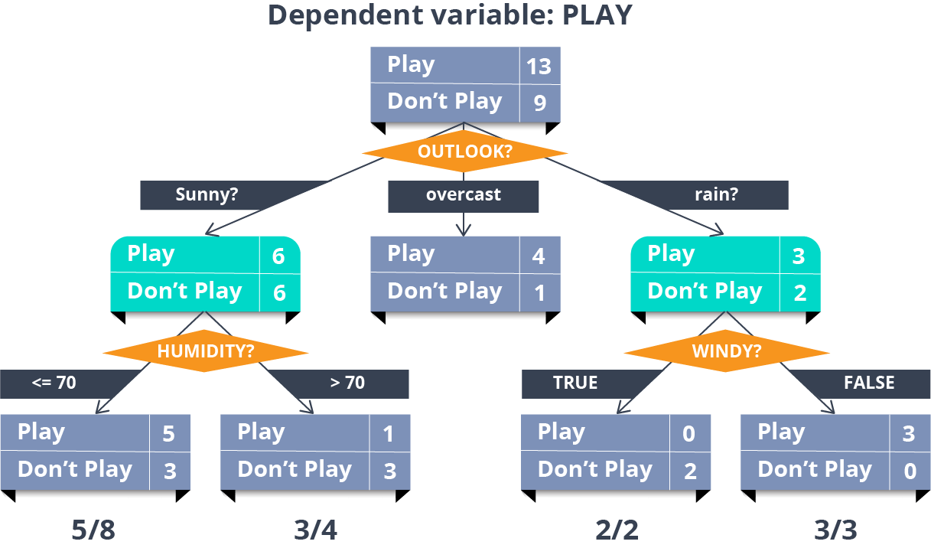

Figure 2.6 Decetion tree

There are three different types of nodes: chance nodes, decision nodes, and end nodes. A chance node, represented by a circle, shows the probabilities of certain results. A decision node, represented by a square, shows a decision to be made, and an end node shows the final outcome of a decision path.

## **Advantages & Disadvantages of Decision Trees**

### **Advantages**

* Decision trees generate understandable rules.
* Decision trees perform classification without requiring much computation.
* Decision trees are capable of handling both continuous and categorical variables.
* Decision trees provide a clear indication of which fields are most important for prediction or classification.

### **Disadvantages**

* Decision trees are less appropriate for estimation tasks where the goal is to predict the value of a continuous attribute.
* Decision trees are prone to errors in classification problems with many class and a relatively small number of training examples.
* Decision trees can be computationally expensive to train. The process of growing a decision tree is computationally expensive. At each node, each candidate splitting field must be sorted before its best split can be found. In some algorithms, combinations of fields are used and a
* search must be made for optimal combining weights. [**Pruning algorithms**](https://www.edureka.co/blog/implementation-of-decision-tree/) can also be expensive since many candidate sub-trees must be formed and compared.
* **Creating a Decision Tree**

Let us consider a scenario where a new planet is discovered by a group of astronomers. Now the question is whether it could be ‘the next earth?’ The answer to this question will revolutionize the way people live. Well, literally!

There is n number of deciding factors which need to be thoroughly researched to take an intelligent decision. These factors can be whether water is present on the planet, what is the temperature, whether the surface is prone to continuous storms, flora and fauna survives the climate or not, etc.

Let us create a decision tree to find out whether we have discovered a new habitat.

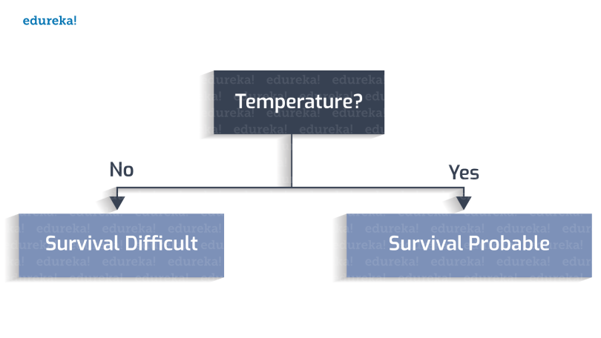The habitable temperature falls into the range 0 to 100 Celsius.

Figure 2.7 : Creating a Decision Tree

* **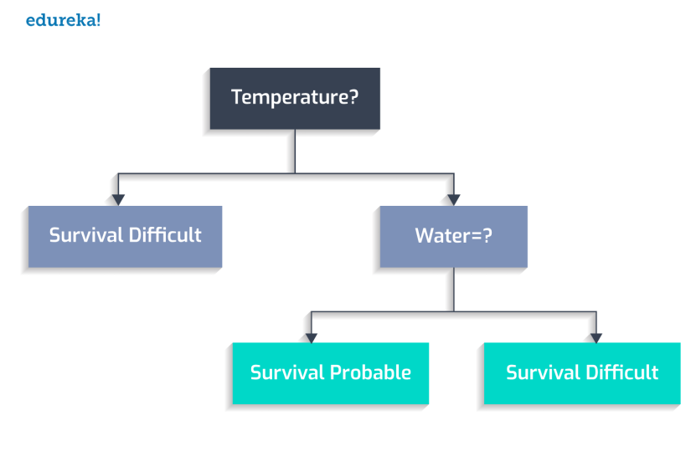Whether water is present or not?**

Figure 2.8 : Creating a Decision Tree

* **Whether flora and fauna flourishes?**

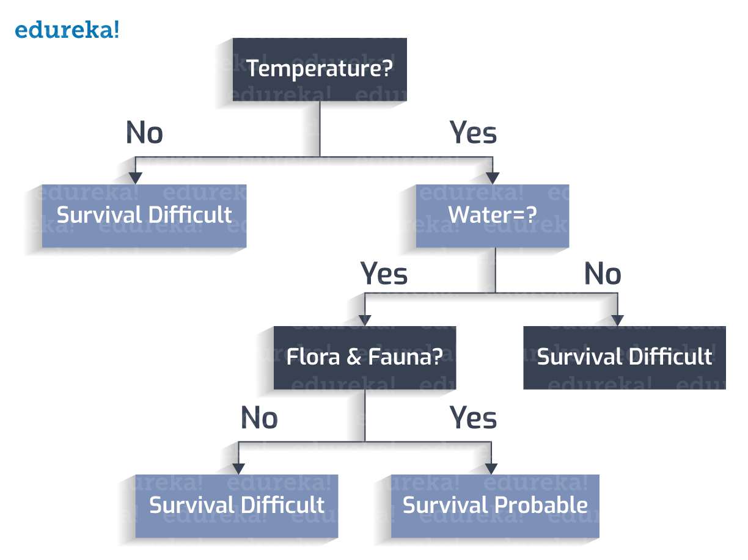

Figure 2.9: Creating a Decision Tree

* **The planet has a stormy surface?**

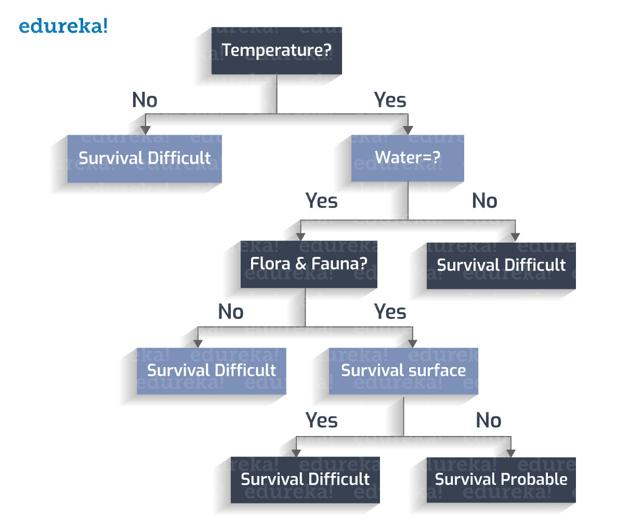

Figure 2.10 : Creating a Decision Tree

## **Classification Rules:**

Classification rules are the cases in which all the scenarios are taken into consideration and a class variable is assigned to each.

### **Class Variable:**

Each leaf node is assigned a class-variable. A class-variable is the final output which leads to our decision.

Let us derive the classification rules from the Decision Tree created:

1. If Temperature is not between 273 to 373K, -> Survival Difficult

2. If Temperature is between 273 to 373K, and  water is not present, -> Survival Difficult

3. If Temperature is between 273 to 373K, water is present, and flora and fauna is not present -> Survival Difficult

4. If Temperature is between 273 to 373K, water is present, flora and fauna is present, and a stormy surface is not present -> Survival Probable

5. If Temperature is between 273 to 373K, water is present, flora and fauna is present, and a stormy surface is present -> Survival Difficult

* **Decision Tree**

A decision tree has the following constituents :

* Root Node: The factor of ‘temperature’ is considered as the root in this case.
* Internal Node: The nodes with one incoming edge and 2 or more outgoing edges.
* Leaf Node: This is the terminal node with no out-going edge.

As the decision tree is now constructed, starting from the root-node we check the test condition and assign the control to one of the outgoing edges, and so the condition is again tested and a node is assigned. The decision tree is said to be complete when all the test conditions lead to a leaf node. The leaf node contains the class-labels, which vote in favor or against the decision.

Now, you might think why did we start with the ‘temperature’ attribute at the root? If you choose any other attribute, the decision tree constructed will be different.Correct. For a particular set of attributes, there can be numerous different trees created. We need to choose the optimal tree which is done by following an algorithmic approach. We will now see ‘the greedy approach’ to create a perfect decision tree.

## Random Forest Classification

Classification is the method of predicting the class of a given input data point. Classification problems are common in machine learning and they fall under the Supervised learning method.

Let’s say you want to classify your emails into 2 groups, spam and non-spam emails. For this kind of problems, where you have to assign an input data point into different classes, you can make use of classification algorithms.

Under classification we have 2 types:

* Binary Classification
* Multi-Class Classification

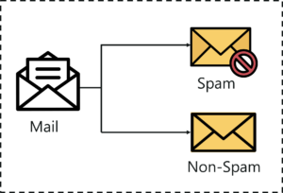

Figure 2.11 : Example

The example that I gave earlier about classifying emails as spam and non-spam is of binary type because here we’re classifying emails into 2 classes (spam and non-spam).

But let’s say that we want to classify our emails into 3 classes:

* Spam messages
* Non-Spam messages
* Drafts

So here we’re classifying emails into more than 2 classes, this is exactly what multi-class classification means.

One more thing to note here is that it is common for classification models to predict a continuous value. But this continuous value represents the probability of a given data point belonging to each output class.

* 1. **CODE :**
  2. from flask import Flask, render\_template, request
  3. from chatterbot import ChatBot
  4. from chatterbot.trainers import ChatterBotCorpusTrainer
  5. app = Flask(\_\_name\_\_)
  6. english\_bot = ChatBot("Chatterbot", storage\_adapter="chatterbot.storage.SQLStorageAdapter")
  7. trainer = ChatterBotCorpusTrainer(english\_bot)
  8. trainer.train("chatterbot.corpus.english")
  9. @app.route("/")
  10. def home():
  11. return render\_template("index.html")
  12. @app.route("/get")
  13. def get\_bot\_response():
  14. userText = request.args.get('msg')
  15. return str(english\_bot.get\_response(userText))
  16. if \_\_name\_\_ == "\_\_main\_\_":
  17. app.run()

**3.0 RESULT SECTION**

* **3.1 SNAPSORT OF TRANNING AND ACCURACY LEVEL**

**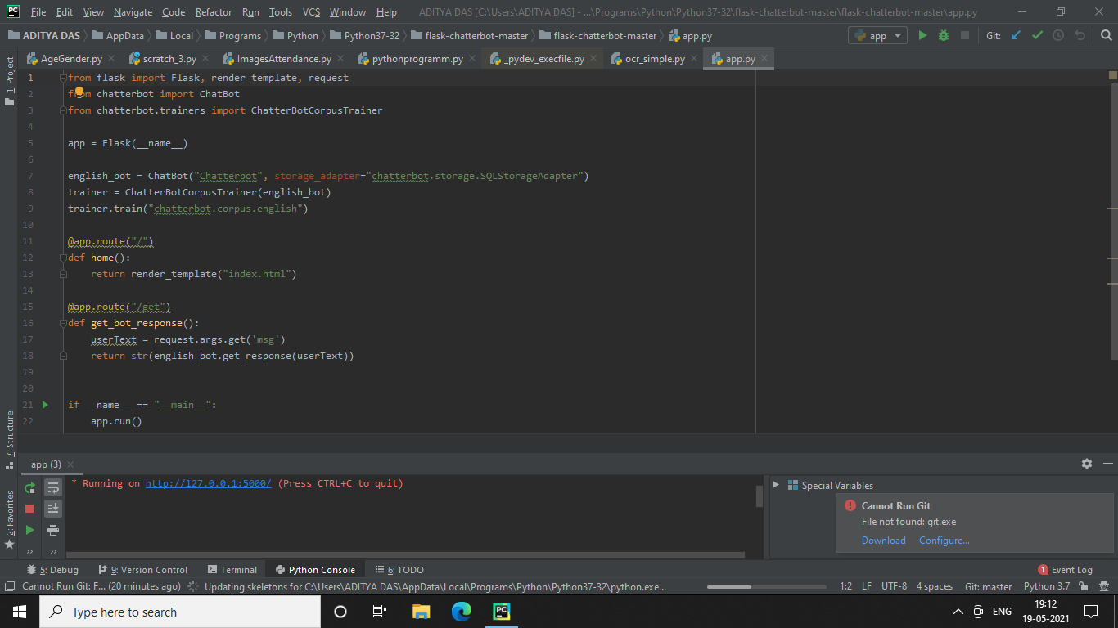**

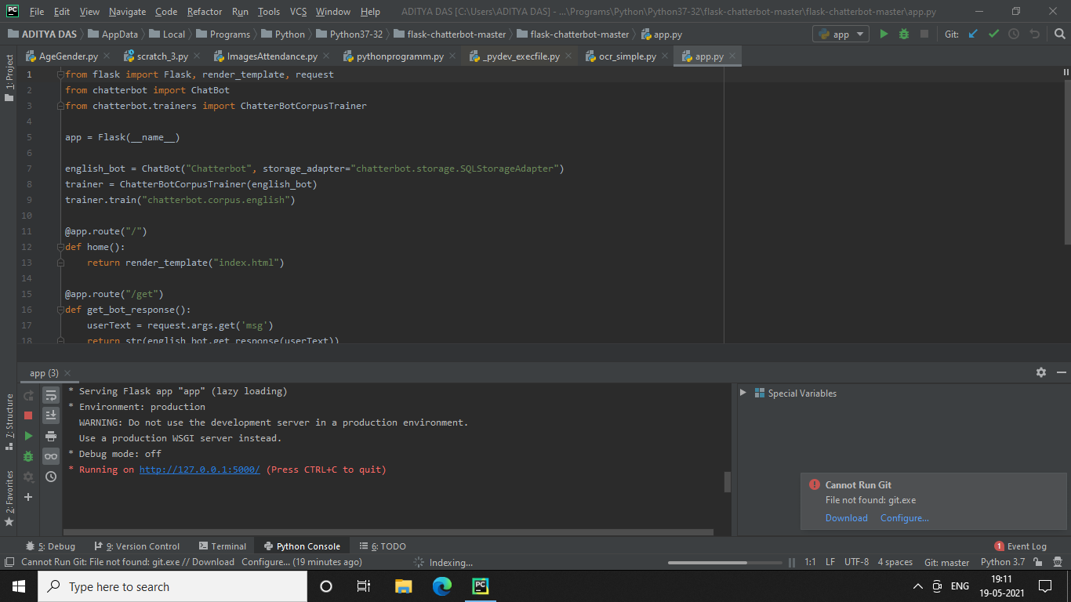

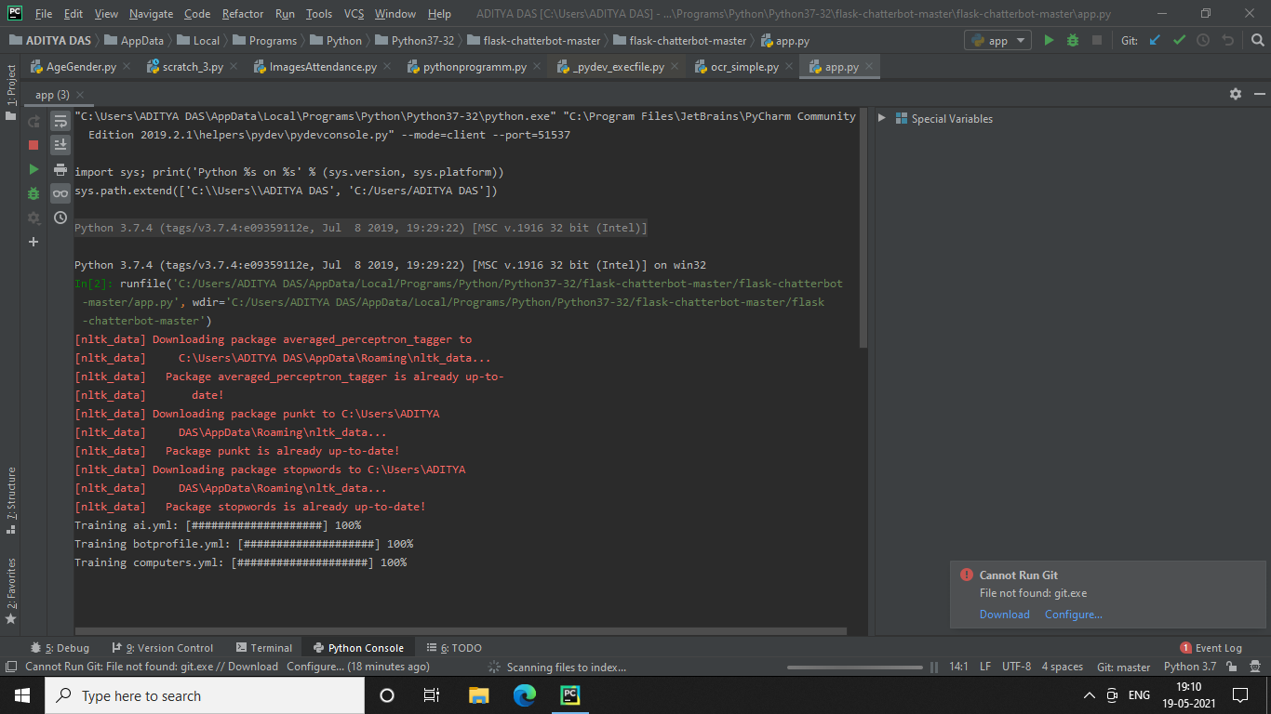

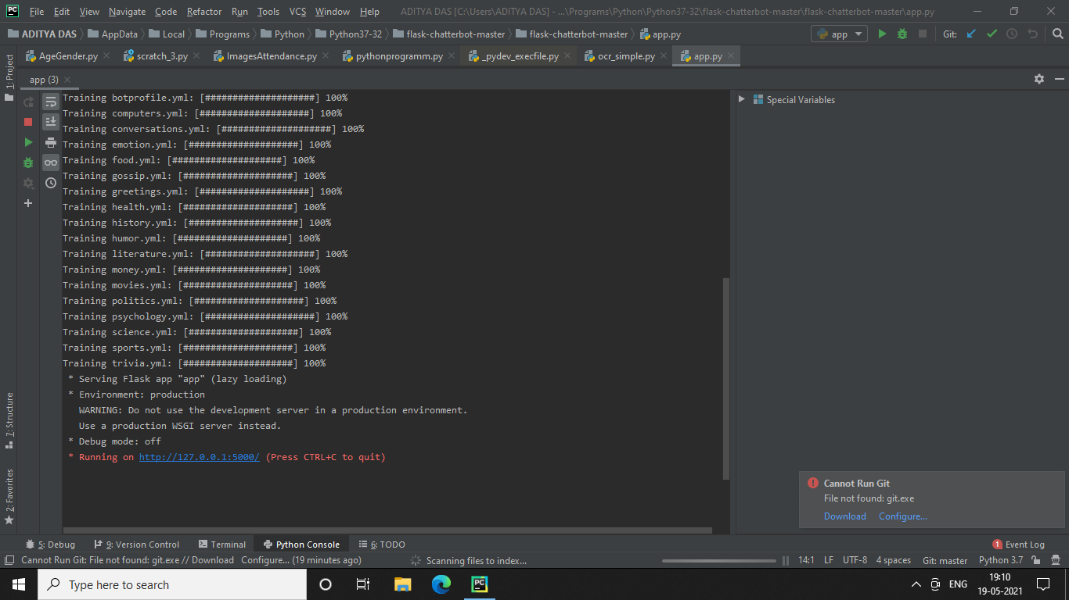

**3.2 TESTING**

* **UNIT TESTING**

Unit is undertaken after coding of a module is complete, all syntax errors have been reomoved, and the code has been reviewed. This activity is typically undertaken by the coder of the module himself in the coding phase. Before carrying out unit testing, the unit test cases have to be designed and the test environment for the unit under test has to be developed. In this section, we first discuss the environment needed to perform unit testing.

Driver and stub modules

In order to test a single module, we need a complete environment to provide all relevant code that is necessary for execution of the module. That is, besides the module under ties the following are needed to test the module:

* The procedures belonging to other modules that the module under test calls.
* Non-local data structures that the module accesses.
* A procedure to call the functions of the module under test with appropriate parameters.

Modules required to provide the necessary environment (which either call, provide the required global data, or are called by the module under test) are usually not available unit

They too have been unit tested. In this context, stubs and drivers are designed to provide the complete environment for a module so that testing can be carried out. The role of stub and driver modules is pictorially shown in Figure 10.3. We briefly discuss the stub and driver modules that are required to provide the necessary environment for carrying out unit testing are briefly discussed in the following.

**Stub:** A sub module consists of several stub procedures that are called by the module under test. A stub procedure is a dummy procedure that takes the same parameters as the function called by the unit under test but has a highly simplified behavior. For example, a stub procedure may produce the expected behavior using a simple table look up

mechanism, rather than performing actual computations.

Driver

Module under text

Stub

FIGURE Unit testing with the help of driver and stub modules.

**Driver:** A driver module contains the non-local data structures that are accessed by the module under test. Additionally, it should also have the code to call the different functions of the unit under test with appropriate parameter values for testing.

* **BLACK-BOX TESTING**

In black-box testing, test cases are designed from an examination of the input/output values only and no knowledge of design or code is required. The following are the two main approaches available to design black box test cases:

* Equivalence class partitioning
* Boundary value analysis

In the following subsections, we will elaborate these two test case design techniques.

* Equivalence Class Partitioning

In the equivalence class partitioning approach, the domain of input values to the unit under test is partitioned into a set of equivalence classes. The partitioning is done such that for every input data belonging to the same equivalence class, the program behaves similarly. Equivalence classes for a unit under test can be designed by examining the input data and output data. The following are two general guidelines for designing the equivalence classes:

* If the input data values to a system can be specified by a range of values, then one valid and two invalid equivalence classes can be defined. For example, if the equivalence class is the set of integers in the range 1 to 10 (i.e., [1, 10]), then the two invalid equivalence classes are [- ,0], [11,+ ] and the valid equivalence class is [1,10].
* If the input data assumes values from a set of discrete members of some domain, then one equivalence class for the valid input values and another equivalence class for the invalid input values should be defined. For example, if the valid equivalence classes are {A, B, C), then the invalid equivalence class is U-{A,B,C}, where U is the universe of all possible input values.
* Boundary Value Analysis

A type of programming error that is frequency committed by programmers is missing out on the special consideration that should be to the values at the boundaries of different equivalence classes of inputs. The reason behind programmers committing such errors might purely be due to psychological factors. Programmers often fail to properly address the special processing required by the input values that lie at the boundary of the different equivalence classes. For example, a programmer may improperly use < instead of <=, or conversely <= for <, etc...)

To design boundary value test cases, it is required to examine the equivalence classes to check if any of the equivalence classes contains a range of values. For those equivalence classes that are not a range of values (i.e., consist of a discrete collection of values) no boundary value test cases can be defined. For an equivalence class that is a range of values, the boundary values need to be included in the test suite. For example, if equivalence contains the integers in the range 1 to 10, then the boundary value test suite is {0, 1, 10, 11}.

* Summary of the Black-box Test Suite Design Approach

We now summarise the important steps in the black-box test suite design approach:

* Examine the input and output values of the program.
* Identify the equivalence classes.
* Design equivalence class test cases by picking one representative value from each equivalence class.
* Design the boundary value test cases as follows. Examine if any equivalence class is a range of values. Include the values at the boundaries of such equivalence classes in the test suite.

The strategy for black-box testing is intuitive and simple. For black-box testing, the most important step is the identification of the equivalence classes. Often, the identification of the equivalence classes is not straightforward. However, with little practice one would be able to identify all equivalence classes in the input data domain. Without practice, one may overlook many equivalence classes in the input data set. Once the equivalence classes are identified, the equivalence class and boundary value test cases can be selected almost mechanically.

* **WHITE-BOX TESTING**

White-box testing is an important type of unit testing. A large number of white-box testing strategies exist. Each testing strategy essentially designs test cases based on analysis of some aspect of source code and is based on some heuristic. We first discuss some basic concepts associated with white-box testing, and follow it up with a discussion on specific testing strategies.

* Basic Concepts

A white-box testing strategy can either be coverage-based or fault-based.

Fault-based testing

A fault-based testing strategy targets to detect certain types of faults. An example of a fault-based strategy is mutation testing, which is discussed later in this section.

Coverage-based testing

A coverage-based testing strategy attempts to execute (or cover) certain elements of a program. Popular examples of coverage-based testing strategies are statement branch coverage, multiple condition coverage, and path coverage-based testing.

* **INTEGRATION TESTING**

Integration testing is carried out after all (or at least some of) the modules have been unit tested. Successful completion of unit testing, to a large extent, ensures that the unit (or module) as a whole works satisfactorily. In this context, the objective of integration testing is to detect the errors at the module interfaces (call parameters). For example, it is checked that no parameter mismatch occurs when one module invokes the functionality of another module. Thus, the primary objective of integration

testing is to test the module interfaces, i.e., there are no

errors in parameter passing, when one module invokes the functionality of another module.

During integration testing, different modules of a system are integrated in a planned manner using an integration plan. The integration plan specifies the steps and the order in which modules are combined to realise the full system. After each integration step, the partially integrated system is tested.

An important factor that guides the integration plan is the module dependency graph. Thus, by examining the structure chart, the integration plan can be developed. Any one (or a mixture) of the following approaches can be used to develop the test plan:

* Big-bang approach to integration testing
* Top-down approach to integration testing
* Bottom-up approach to integration testing
* Mixed (also called sandwiched) approach to integration testing

In the following subsections, we provide an overview of these approaches to integration testing.

* Big-bang approach to integration testing

Big-bang testing is the most obvious approach to integration testing. In this approach, all the modules making up a system are integrated in a single step. In simple words, all the unit tested modules of the system are simply linked together and tested. However, this technique can meaningfully be used only for very small systems. The main problem with this approach is that once a failure has been detected during integration testing, it is very difficult to localise the error as the error may potentially exist in any of the modules. Therefore, debugging errors reported during big-bang integration testing are very expensive to fix. As a result, bing-bang integration testing is almost never used for large programs.

* Bottom-up approach to integration testing

Large software products are often made up of several subsystems. A subsystem might consist of many modules which communicate among each other through well defined interfaces. In bottom-up integration testing, first the modules for the each subsystem are integrated. Thus, the subsystems can be integrated separately and independency.

The primary purpose of carrying out the integration testing a subsystem is to test whether the interfaces among various modules making up the subsystem work satisfactorily. The test cases must be carefully chosen to exercise the interfaces in all possible manners.

In a pure bottom-up testing no stubs are required, and only test-drivers are required. Large software systems normally require several levels of subsystem testing, lower-level subsystems are successively combined to form higher-level subsystems. The principal advantage of bottom-up integration testing is that several disjoint subsystems can be tested simultaneously. Another advantage of bottom-up testing is that the low-level modules get tested thoroughly, since they are exercised in each integration step. Since the low-level modules do I/O and other critical functions, testing the low-level modules thoroughly increases the reliability of the system. A disadvantage of bottom-up testing is the complexity that occurs when the system is made up of a large number of small subsystems that are at the same level. This extreme case corresponds to the big-bang approach.

* Top-down approach to integration testing

Top-down integration testing starts with the root module in the structure chart and one or two subordinate modules of the root module. After the top-level 'skeleton' has been tested, the modules that are at the immediately lower layer of the 'skeleton' are combined with it and tested. Top-down integration testing approach requires the use of program stubs to simulate the effect of lower-level routines that are called by the routines under test. Pure top-down integration does not require any driver routines. An advantage top-down integration testing is that it requires writing only stubs, and stubs are simpler to write compared to drivers. A disadvantage of the top-down integration testing approach is that in the absence of lower-level routines, it becomes difficult to exercise the top-level routines in the desired manner since the lower level routines usually perform input/output (I/0) operations.

* **SYSTEM TESTING**

After all the units of a program have been integrated

together and tested, system testing is taken up.

The system testing procedures are the same for both

object-oriented and procedural programs, since system test cases are designed solely based on the SRS document and the actual implementation (procedural or object-oriented) is immaterial.

There are three main kinds of system testing. These are essentially similar tests, but differ in who carries out the testing:

* **Alpha Testing**: Alpha testing refers to the system testing carried out by the test team within the developing organisation.
* **Beta Testing**: Beta testing is the system testing performed by a select group of friendly customers.
* **Acceptance Testing**: Acceptance testing is the system testing performed by the customer to determine whether to accept the delivery of the system.

As can be observed from the above discussions, in the different types of system tests, the test cases can be the same,but the difference is with respect to who designs test cases and carries out testing.

Before a fully integrated system is accepted for system testing, smoke testing is performed. Smoke testing is done to check whether at least the main functionalities of the software are working properly. Unless the software is stable and at least the main functionalities are working satisfactorily, system testing is not undertaken.The functionality tests are designed to check whether the software satisfies the functional requirements as documented in the SRS document. The performance tests, on the other hand, test the conformance of the system with the non-functional requirements of the system. We have already discussed how to design the functionality test cases by using a black-box approach. So, in the following subsection we discuss only smoke and performance testing.

**3.3 CONCLUSION AND FUTURE SCOPE**

**CONCLUTION AND FUTURE SCOPE**

**1. AI in Science and Research**

AI is making lots of progress in the scientific sector. Artificial Intelligence can handle large quantities of data and processes it quicker than human minds. This makes it perfect for research where the sources contain high data volumes.

AI is already making breakthroughs in this field. A great example is ‘Eve,’ which is an AI-based robot. It discovered an ingredient of toothpaste that can cure a dangerous disease like Malaria. Imagine a common substance present in an everyday item that is capable of treating Malaria; it’s a significant breakthrough, no doubt.

Drug discovery is a fast-growing sector, and AI is aiding the researchers considerably in this regard. Biotechnology is another field where researchers are using AI to design microorganisms for industrial applications. Science is witnessing significant changes thanks to AI and ML. Learn more about the [benefits of AI.](https://www.upgrad.com/blog/benefits-of-artificial-intelligence/)

**2. AI in Cyber Security**

Cybersecurity is another field that’s benefitting from AI. As organizations are transferring their data to IT networks and cloud, the threat of hackers is becoming more significant.

One triumphant attack can wreak havoc on an organization. To keep their data and resources secure, organizations are making massive investments in cybersecurity. The future scope of AI in cybersecurity is bright.

Cognitive AI is an excellent example of this field. It detects and analyses threats, while also providing insights to the analysts for making better-informed decisions. By using [Machine Learning algorithms](https://www.upgrad.com/blog/top-applications-of-machine-learning-algorithms-using-cloud/) and Deep Learning networks, the AI gets better and more durable over time. This makes it capable of fighting more advanced threats that might develop with them.

 Many institutions are using AI-based solutions to automate the repetitive processes present in cybersecurity. For example, IBM has [IBM Resilient](https://www.ibm.com/in-en/security/artificial-intelligence), which is an agnostic and open platform that gives infrastructure and hub for managing security responses.

Another field is fraud detection. AI can help in detecting frauds and help organizations and people in avoiding scams. For example, [Recurrent Neural Networks](https://www.upgrad.com/blog/recurrent-neural-network-in-python/) are capable of detecting fraud in their early stages. They can scan extensive quantities of transactions quickly and classify them according to their trustworthiness. By identifying fraudulent transactions and tendencies, organizations can save a lot of time and resources. It surely lessens the risk of losing money.

**3. AI in Data Analysis**

Data analysis can benefit largely from AI and ML. [AI algorithms](https://www.upgrad.com/blog/types-of-artificial-intelligence-algorithms/) are capable of improving with iterations, and this way, their accuracy, and precision increase accordingly. AI can help data analysts with handling and processing large datasets.

AI can identify patterns and insights that human eyes can’t notice without putting in a lot of effort. Moreover, it is faster and more scalable at doing so. For example, Google Analytics has [Analytics Intelligence](https://support.google.com/analytics/answer/7411707?hl=en), which uses machine learning to help webmasters get insights on their websites faster.

You can ask Analytics Intelligence a question in simple English, and it would give you a prompt reply. It also provides webmasters with Smart Lists, Smart Goals, Conversion Probability, and other features that help the webmaster in improving the results of their site.

The scope of AI in data analytics is rising rapidly. Another example of AI applications in this sector is predicting outcomes from data. Such systems use the analytics data to predict results and the appropriate course of action to achieve those results. Learn more about [AI applications.](https://www.upgrad.com/blog/types-of-artificial-intelligence-algorithms/)

As mentioned earlier, AI systems can handle tons of data and process it much faster than humans. So, they can take customer data and make more accurate predictions of customer behavior, preferences, and other required factors. [Helixa.ai](http://www.helixa.ai/) is a great example of such an AI application. They use AI to provide insights into customer (or audience) behavior for higher accuracy and better results. Agencies and marketers can use their services to build precise buyer personas and create better-targeted ad campaigns.

**4. AI in Transport**

The transport sector has been using AI for decades. Airplanes have been using autopilot to steer them in the air [since 1912](https://en.wikipedia.org/wiki/Autopilot). An autopilot system controls the trajectory of a plane, but it isn’t restricted to aircraft alone. Ships and spacecraft also use autopilot to help them maintain the correct course.

Autopilot helps the human operator and assists them in heading in the right direction. A pilot of a modern aircraft usually works for 7 minutes; the autopilot handles most of the steering of the plane. This allows the pilots to focus on other more important areas of the flight, such as the weather and the trajectory of the plane.

Another area where the future scope of AI is quite broad is driverless cars. Many companies are developing autonomous vehicles, which will rely heavily on AI and ML to operate optimally. Experts believe [self-driving cars](https://www.upgrad.com/blog/how-machine-learning-algorithms-made-self-driving-cars-possible/) will bring many long-term and short-term benefits, including lower emissions and enhanced road safety. For example, self-driving cars will be free from human errors, which account for 90% of traffic accidents. Many companies, including Tesla and Uber, are developing these vehicles.

**5. AI in Home**

AI has found a special place in people’s homes in the form of Smart Home Assistants. Amazon Echo and Google Home are popular smart home devices that let you perform various tasks with just voice commands.

You can order groceries, play music, or even switch on/off the lights in your living room with just a few voice commands. Both of them rely on [Voice Recognition technologies](https://www.upgrad.com/blog/voice-search-technology-quick-facts/), which are a result of Artificial Intelligence and Machine Learning. They constantly learn from the commands of their users to understand them better and become more efficient.

Smart assistants are also present in mobile phones. Apple’s Siri and Google Assistant are great examples of this sort. They also learn to recognize their users’ voices to interpret them better all the time. And they can perform a plethora of tasks. Microsoft also has a smart assistant, which is called Cortana.

You can use these smart assistants for various tasks such as:

* Playing a song
* Asking a question
* Buying something online
* Opening an app

There’s a lot of room left for improvement, but surely, the scope of AI in the smart home sector is booming.

**6. AI in Healthcare**

The medical sector is also using this technology for its advantages. AI is helping medical researchers and professionals in numerous ways.

For example, the Knight Career Institute and Intel have [made a collaborative cancer cloud](https://news.ohsu.edu/2016/03/31/dana-farber-cancer-institute-and-ontario-institute-for-cancer-research-join-collaborative-cancer-cloud). This cloud takes data from the medical history of cancer (and similar) patients to help doctors in making a better diagnosis. Preventing cancer from moving to higher stages is its most effective treatment at this time.

We’ve already mentioned how AI is helping researchers in their field too. Apart from finding a cure for cancer, some organizations are using AI to help patients get telemedicine. The [UK’s National Health Service](https://en.wikipedia.org/wiki/National_Health_Service) uses Google’s DeepMind platform to detect health risks in people through apps.

Wrong diagnoses are a significant problem in the medical sector. AI can help doctors in avoiding these errors by providing them with relevant databases and recommendations. It can analyze the database of patients with similar symptoms and suggest the treatment that was the most successful in those cases.

Many major organizations, including IBM and Microsoft, are collaborating with medical institutions to solve the various problems present in the healthcare sector.

AI can also help in reducing medical costs by preventing diseases beforehand and helping doctors in making better diagnoses. BCIs (Brain-computer Interfaces) is another area where the medical sector is utilizing AI. These interfaces help in predicting problems related to speaking or moving that might develop due to problems in the brain. They use AI to help these patients overcome these issues, too, by decoding neural activates.